# Violin Plot of Turbulent Personalities Distribution

## Turbulent Analysts (INTJ, INTP, ENTP, ENTJ)

### #Setting Work Directory

setwd('E:/AED/Tugas M10')

### #Input Data

data=read.table('E:/AED/Tugas M10/countries.csv',header=TRUE,sep=',')

### #Install Library ggplot2

library(ggplot2)

### #Memilah dan menggabungkan data MBTI tipe Analysts (INTJ, INTP, ENTP, ENTJ) dengan function stack

df1 = stack(data[,c(13,22,25,27)])

### #Menamai kolom dari dataframe di atas

colnames(df1) = c("Distribusi", "MBTI")

### #Membuat baseline violin plot dan menampilkannya

analysts = ggplot(df1,aes(x=factor(MBTI),y=Distribusi))+geom_violin(trim=FALSE)

analysts

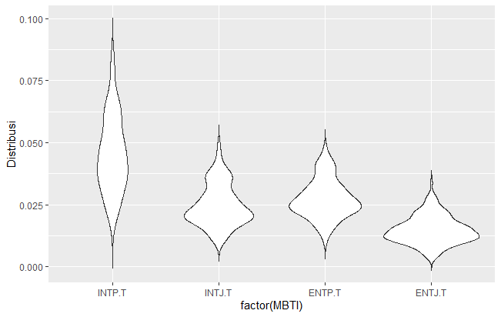

### #Mengisi warna dari violin plot dan menambah legend

analysts = ggplot(df1,aes(x=factor(MBTI),y=Distribusi,fill=factor(MBTI)))+

geom_violin(trim=FALSE)

analysts

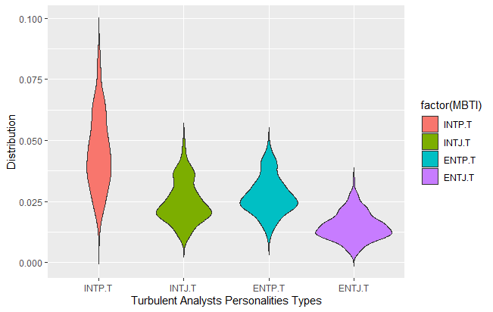

### #Mengubah nama axis

analysts = ggplot(df1,aes(x=factor(MBTI),y=Distribusi,fill=factor(MBTI)))+

geom_violin(trim=FALSE) + labs(x="Turbulent Analysts Personalities Types", y="Distribution")

analysts

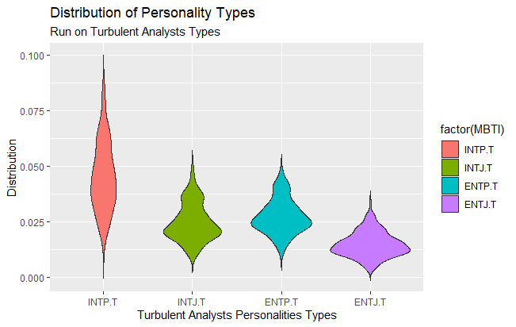

### #Menambahkan judul dan takarir

analysts = ggplot(df1,aes(x=factor(MBTI),y=Distribusi,fill=factor(MBTI))) +

geom_violin(trim=FALSE) + labs(x="Turbulent Analysts Personalities Types",

y="Distribution",

title="Distribution of Personality Types",

subtitle="Run on Turbulent Analysts Types")

analysts

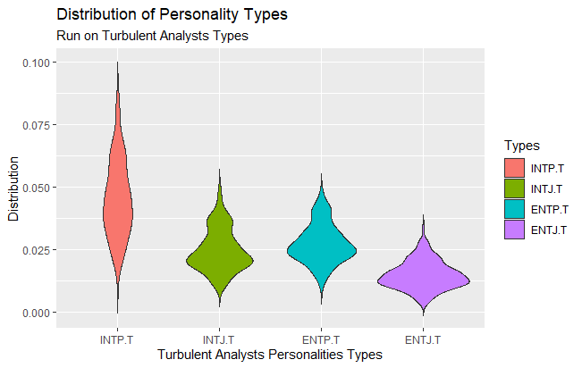

### #Mengubah judul pada legend

analysts = ggplot(df1,aes(x=factor(MBTI),y=Distribusi,fill=factor(MBTI))) +

geom_violin(trim=FALSE) + labs(x="Turbulent Analysts Personalities Types",

y="Distribution",

title="Distribution of Personality Types",

subtitle="Run on Turbulent Analysts Types",

fill="Types")

analysts

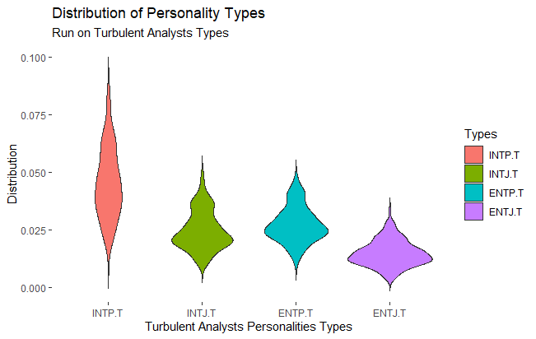

### #Menghilangkan kotak background

analysts = ggplot(df1,aes(x=factor(MBTI),y=Distribusi,fill=factor(MBTI))) +

geom_violin(trim=FALSE) + labs(x="Turbulent Analysts Personalities Types",

y="Distribution",

title="Distribution of Personality Types",

subtitle="Run on Turbulent Analysts Types",

fill="Types") +

theme(rect=element_blank())

analysts

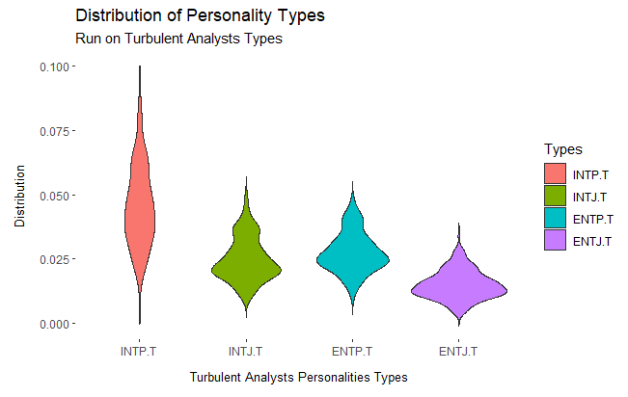

### #Mengatur margin x dan y axis

analysts = ggplot(df1,aes(x=factor(MBTI),y=Distribusi,fill=factor(MBTI))) +

geom_violin(trim=FALSE) + labs(x="Turbulent Analysts Personalities Types",

y="Distribution",

title="Distribution of Personality Types",

subtitle="Run on Turbulent Analysts Types",

fill="Types") +

theme(rect=element_blank(), axis.title.x = element_text(margin=margin(b=5, t=10), size=10),

axis.title.y = element_text(margin=margin(l=5, r=10), size=10))

analysts



### #Menebalkan Judul

analysts = ggplot(df1,aes(x=factor(MBTI),y=Distribusi,fill=factor(MBTI))) +

geom_violin(trim=FALSE) + labs(x="Turbulent Analysts Personalities Types",

y="Distribution",

title="Distribution of Personality Types",

subtitle="Run on Turbulent Analysts Types",

fill="Types") +

theme(rect=element_blank(), axis.title.x = element_text(margin=margin(b=5, t=10), size=10),

axis.title.y = element_text(margin=margin(l=5, r=10), size=10),

plot.title = element_text(face='bold'))

analysts

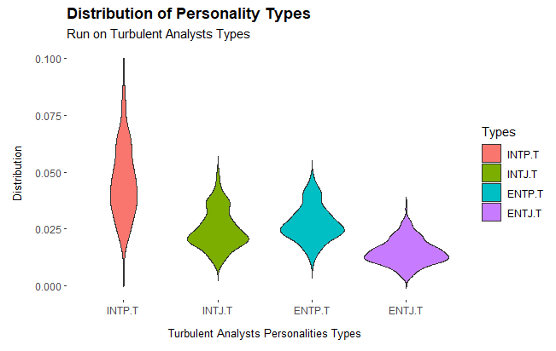

### #Menambahkan Line pada background

analysts = ggplot(df1,aes(x=factor(MBTI),y=Distribusi,fill=factor(MBTI))) +

geom_violin(trim=FALSE) + labs(x="Turbulent Analysts Personalities Types",

y="Distribution",

title="Distribution of Personality Types",

subtitle="Run on Turbulent Analysts Types",

fill="Types") +

theme(rect=element_blank(), axis.title.x = element_text(margin=margin(b=5, t=10), size=10),

axis.title.y = element_text(margin=margin(l=5, r=10), size=10),

plot.title = element_text(face='bold'),

panel.grid=element_line(color='purple'))

analysts

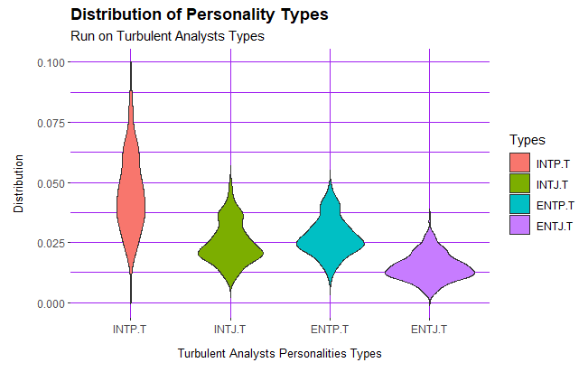

## Turbulent Diplomats (INFP, ENFP, ENFJ, ENFJ)

Dengan syntax yang sama dengan sebelumnya

df2 = stack(data[,c(4,6,14,30)])

colnames(df2) = c("Distribusi", "MBTI")

diplomats = ggplot(df2,aes(x=factor(MBTI),y=Distribusi,fill=factor(MBTI))) +

geom_violin(trim=FALSE) + labs(x="Turbulent Diplomats Personalities Types",

y="Distribution",

title="Distribution of Personality Types",

subtitle="Run on Turbulent Diplomats Types",

fill="Types") +

theme(rect=element_blank(), axis.title.x = element_text(margin=margin(b=5, t=10), size=10),

axis.title.y = element_text(margin=margin(l=5, r=10), size=10),

plot.title = element_text(face='bold'),

panel.grid=element_line(color='green'))

diplomats

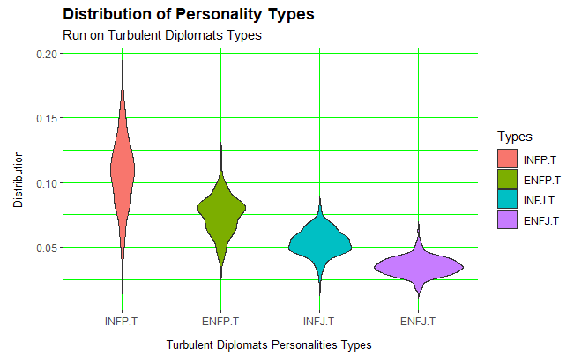

## Turbulent Sentinels (ESFJ, ESTJ, ISFJ, ISTJ)

Dengan syntax yang sama dengan sebelumnya

df3 = stack(data[,c(5,8,9,18)])

colnames(df3) = c("Distribusi", "MBTI")

sentinels = ggplot(df3,aes(x=factor(MBTI),y=Distribusi,fill=factor(MBTI))) +

geom_violin(trim=FALSE) + labs(x="Turbulent Sentinels Personalities Types",

y="Distribution",

title="Distribution of Personality Types",

subtitle="Run on Turbulent Sentinels Types",

fill="Types") +

theme(rect=element_blank(), axis.title.x = element_text(margin=margin(b=5, t=10), size=10),

axis.title.y = element_text(margin=margin(l=5, r=10), size=10),

plot.title = element_text(face='bold'),

panel.grid=element_line(color='blue'))

sentinels

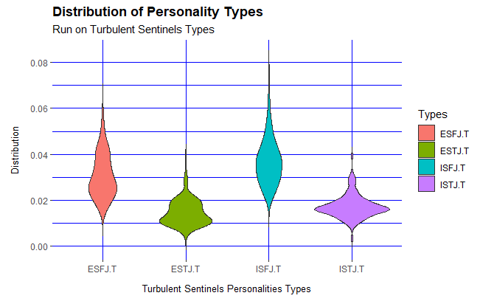

## Turbulent Explorers (ISFP, ESTP, ESFP, ISTP)

Dengan syntax yang sama dengan sebelumnya

df4 = stack(data[,c(15,17,19,26)])

colnames(df4) = c("Distribusi", "MBTI")

explorers = ggplot(df4,aes(x=factor(MBTI),y=Distribusi,fill=factor(MBTI))) +

geom_violin(trim=FALSE) + labs(x="Turbulent Explorers Personalities Types",

y="Distribution",

title="Distribution of Personality Types",

subtitle="Run on Turbulent Explorers Types",

fill="Types") +

theme(rect=element_blank(), axis.title.x = element_text(margin=margin(b=5, t=10), size=10),

axis.title.y = element_text(margin=margin(l=5, r=10), size=10),

plot.title = element_text(face='bold'),

panel.grid=element_line(color='yellow'))

explorers

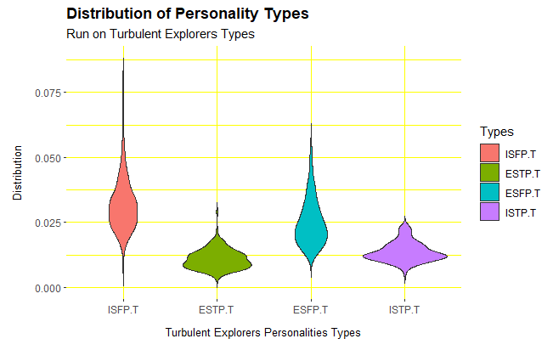

## All Turbulent Personality

Dengan syntax yang sama dengan sebelumnya

all=rbind(df1,df2,df3,df4)

allmbti = ggplot(all,aes(x=factor(MBTI),y=Distribusi,fill=factor(MBTI))) +

geom_violin(trim=FALSE) + labs(x="Turbulent Personalities Types",

y="Distribution",

title="Distribution of Personality Types",

subtitle="Run on All Turbulent Types",

fill="Types") +

theme(rect=element_blank(), axis.title.x = element_text(margin=margin(b=5, t=10), size=10),

axis.title.y = element_text(margin=margin(l=5, r=10), size=10),

plot.title = element_text(face='bold'),

panel.grid=element_line(color='grey'))

allmbti

